PROTOTYPE EXTENSION
Extended User Interface Design of Smart Safety Companion using MIT App Inventor
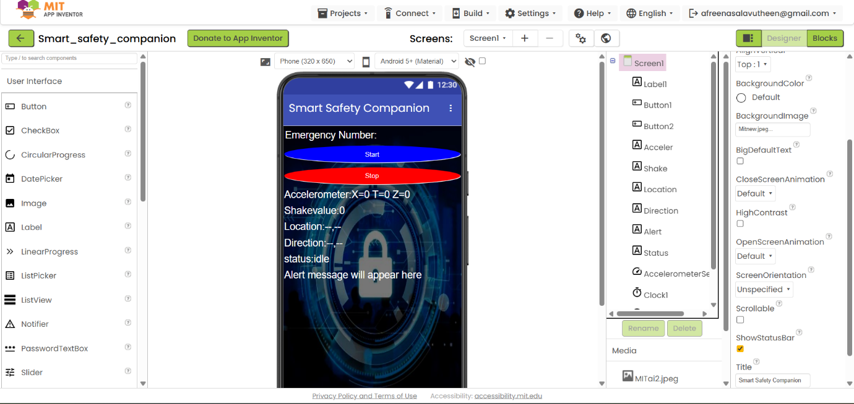
This section presents the extended user interface of the Smart Safety Companion application developed using MIT App Inventor. The interface has been enhanced by adding new interactive components such as monitoring control buttons, sensor information labels, and emergency alert sections.
SYSTEM FUNCTIONALITY
The interface is designed to be user-friendly and easy to navigate.
Start and Stop buttons are provided to control safety monitoring efficiently.
Real-time sensor data is displayed clearly for better understanding.
Location and direction details are shown to assist in tracking the user.
Emergency alerts are displayed.

BLOCK LEVEL IMPLEMENTATION OF SENSOR AND ALERT LOGIC
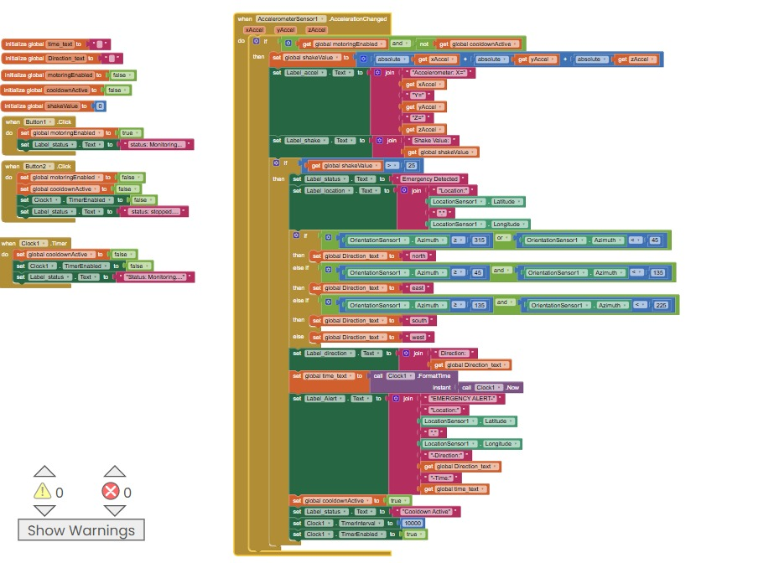
This screenshot illustrates the extended block-level programming used in the prototype. Logical blocks are implemented to process accelerometer readings, detect emergency conditions, track GPS location, and generate alerts automatically.

OUTPUT AND RESULT
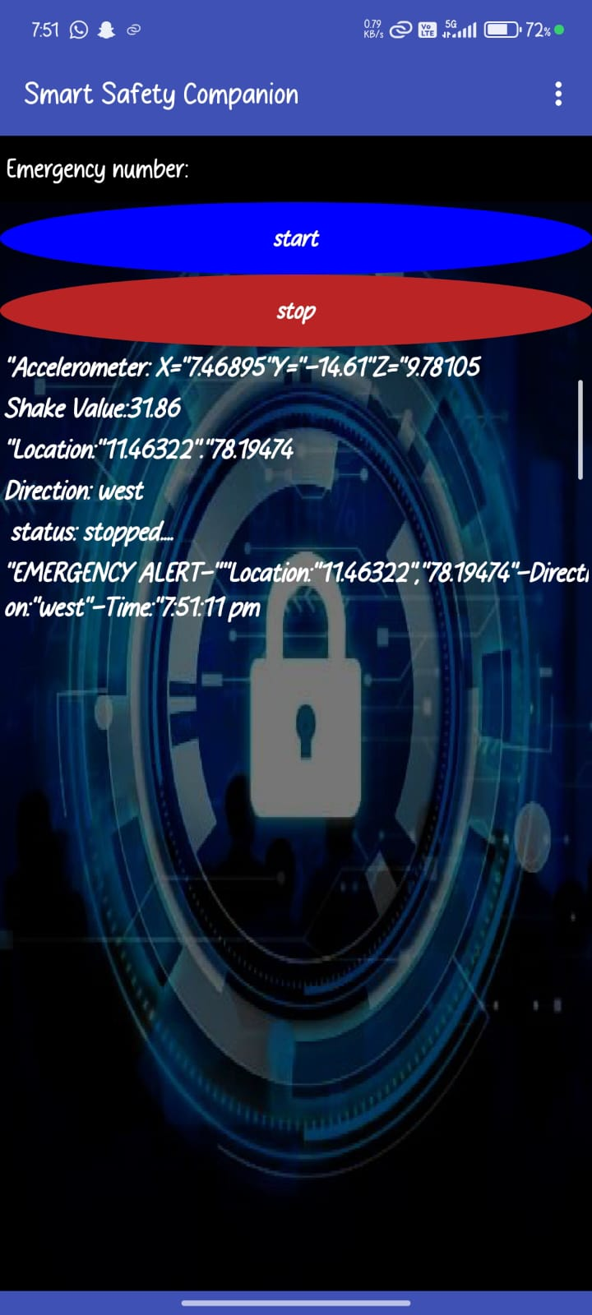
The output screen displays real-time sensor readings, user location, direction details, and alert status. During emergency situations, the system immediately detects abnormal conditions and provides alerts, ensuring quick response and enhanced personal safety.

CONCLUSION
The screenshots demonstrate the successful extension of the original prototype by integrating real-time sensor monitoring, emergency detection, GPS-based location tracking, and automated alert generation. These improvements significantly enhance the reliability, efficiency, and real-world applicability of the Smart Safety Companion.

